Testing system User guide

1. User guide 2

1.1. Testing Station App 2

1.2. Tested OBC App 6

# User guide

## Testing Station App

**Configuring the System**

The application might need specific configuration in order to run properly, because the IP address we used when communicating with the Tested OBC App can be different between system and operation modes. All the application configuration can be done using TestingStationAppSettings.INI file, found where the application is located. In the configuration file you can chose the communication types, UDP (Not recommended), TCP(Recommended) and Local Simulation. The local simulation is an asynchronized mode running without the Tested OBC App while simulating the full application capabilities and can be used to test the environment. For the UDP you need to place both the Testing Station PC IP in the local Ip address field and the Tested OBC PC IP in the destination IP address filed. For TCP you only need to update the local IP and port.

1. Testing Station App configuration. The Source and Destination ports should be the opposite of the Tested OBC App ports.

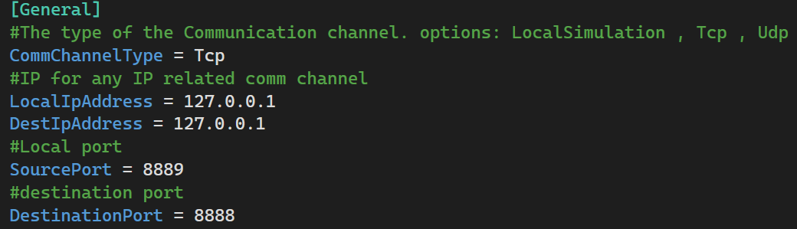

**Top Menu**

In the top of our application we have a menu, containing 3 things:

Tested OBC App Connection indicator:

1. Connection status indicators.







About link, leading to the project book, and User Guide, Leading to a PDF with this guide.

1. Top Menu options.



**Menu**

We have 3 options in the menu, leading to the different pages.

**Home Page**

The Home Page contain instructions on how to create a new test and view the results.

1. Home Page and the Menu.

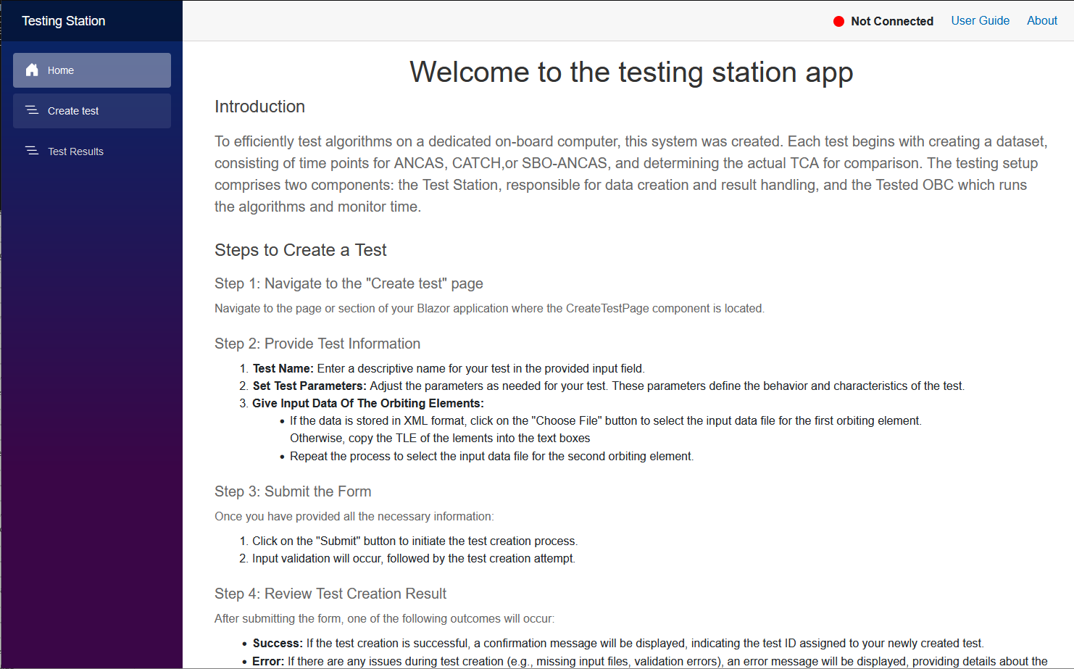

**Creating a new test**

To create a new test, start by navigating to the Create test page:

1. Create tests page.

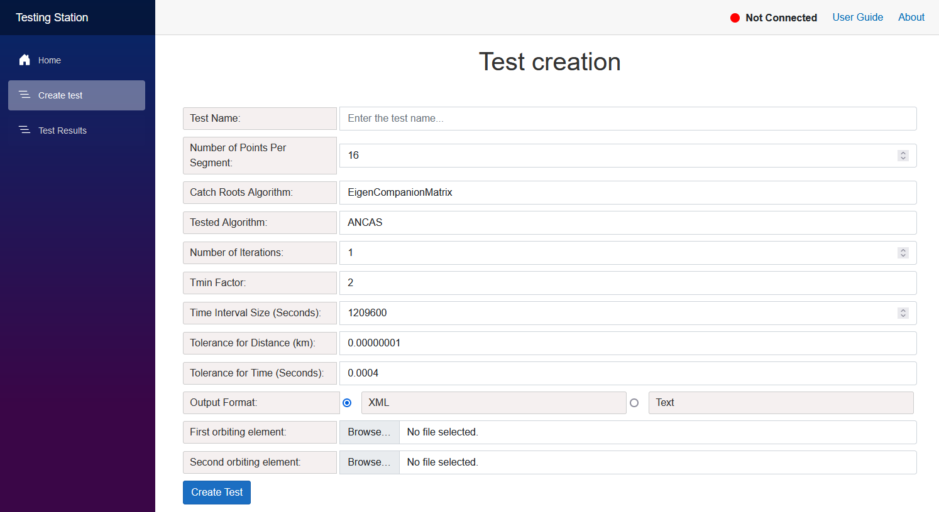

The create test form come with some default values, with number of points per segment set to 16, number of iterations to 1, TminFactor to 2, the time interval to 1 week and the tolerances to their default values.

You start by entering the test name, doesn’t need to be a unique name. after that choose the desired algorithm and enter the input satellites data.

The first input option is XML files, simply choose 2 files from your file system.

1. Test creation with XML format.

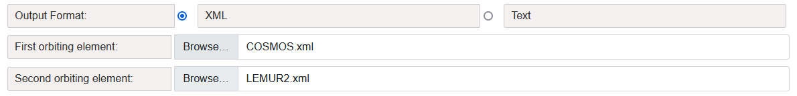

The second input option is TLE, placing the 2 lines of input for each satellite inside the text box as 2 lines.

1. Test creation with the TLE format.

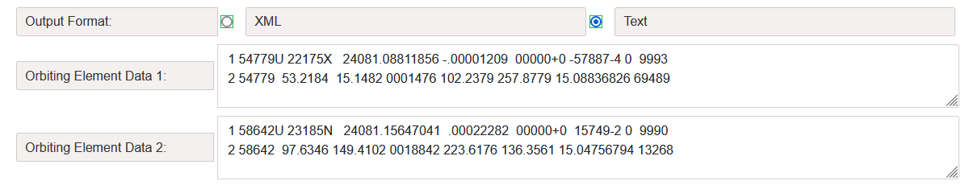

After pressing the Create Test button, if your input was correct, the test will be created and you’ll get the test ID.

1. Test create success message.

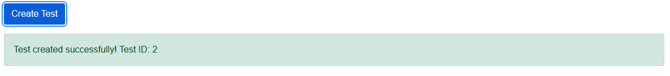

**Watching the tests results**

After creating a test go to the Test results page, when opening you can see a list of the existing tests each with the test name and test statues (Completed, In Progress, Failed).

1. The test Results page.

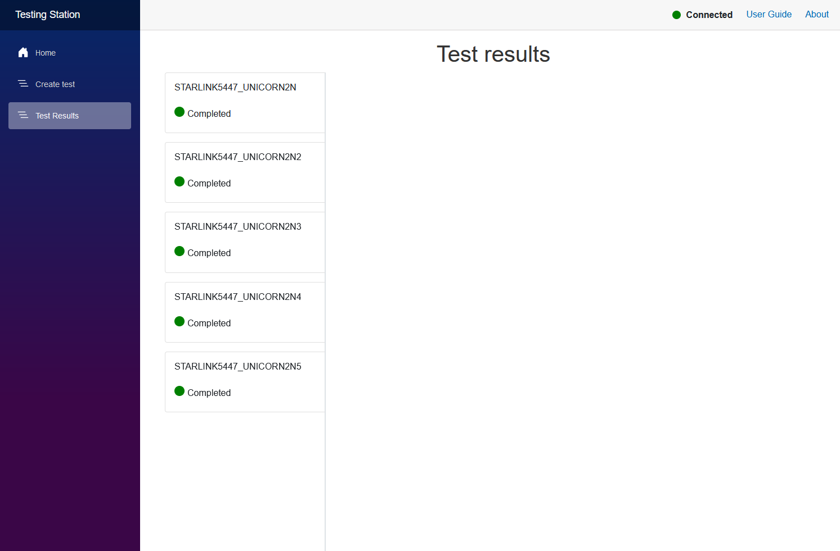

When pressing on one of the tests the test results will be displayed. Almost every value includes tooltip for additional information (formulas, how it was calculated and so on).

1. The test results view.

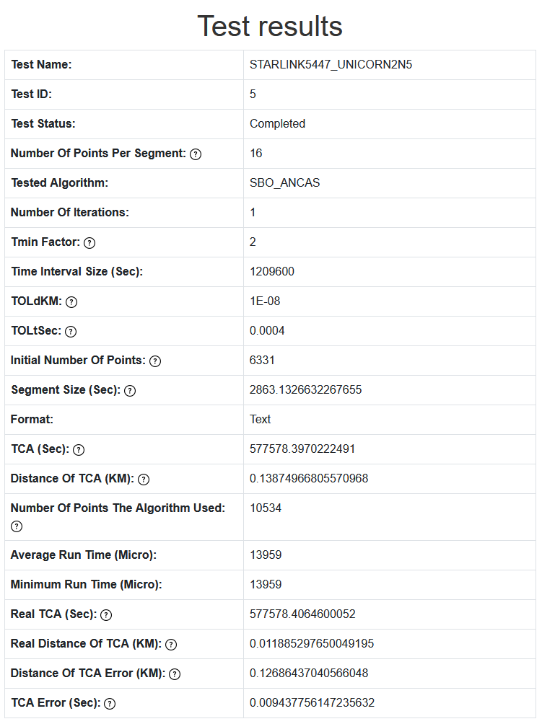

## Tested OBC App

To run the Tested OBC App you only need to set the wanted configuration in the INI file and start the application, found in the released versions folder, the application will continually try to connect to the Testing Station, and when connected will wait for a test request message.

The configuration file contains a few important options you will need to consider.

1. Tested OBC App configuration. The Source and Destination ports should be the opposite of the Testing Station App ports.

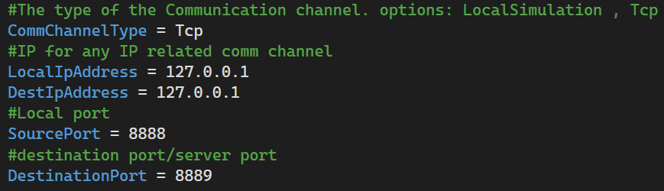

We can decide between three operational modes, Tcp, Local Simulation and Udp (only on windows).

The Local Simulation doesn’t require the Testing Station and run a simple tests case when activated, can be used for testing the target system.

The Tcp option used for communicating with the Testing Station. For TCP we only care about the destination Ip address and port, both should be updated in the file with the Testing System Ip and port. The Udp option is only supported on windows.

After configuring the INI file it should be place in the same folder as the Tested OBC.